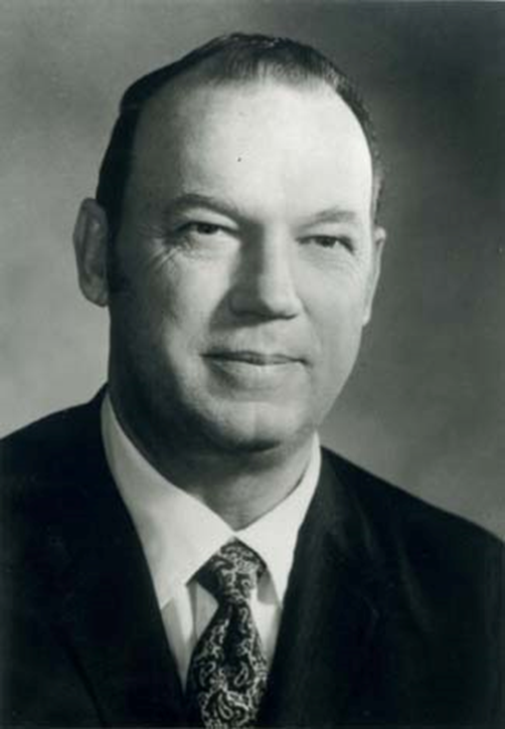
John Boyce “Jay” Pumphrey was born August 5th, 1923 on the family ranch near Old Glory, Texas. Following his graduation from Texas A&M and his service in World War II Mr. Pumphrey returned home to the family ranch. After managing the family ranch for many years Mr. Pumphrey was offered the opportunity to be the general manager for the S. B. Burnett Estates and the Tom L. Burnett Cattle Company. During his tenure with the Burnett Ranches Mr. Pumphrey became an AQHA Director and was elected the 20th president of the AQHA in 1970 making him the youngest president of the AQHA at the time. Mr. Pumphrey firmly believed that Quarter Horses could be introduced abroad and would garner great interest through educational programs outside of the United States. In 1994 Mr. Pumphrey was inducted into the American Quarter Horse Hall of Fame. Before his passing in 2004 Mr. Pumphrey served in many agricultural and veterinary positions due to his professionalism and knowledge of the industry.

